CYB102 Project 7 (🔗 Instructions Page)

👤 Student Name: Shireen M
✉️ Student Email:

Reflection (Required)

🤔 Reflection Question #1: If I had to explain “what is an IOC” in 3 emojis, they would be…
(Feel free to put other comments about your experience in this unit here, too!)
🚩🔍🖥️

🧠Reflection Question #2: If you found out that an IP address was reported malicious a year ago, would you still consider it dangerous? Why or why not?
Yes, I'd still treat it as dangerous from a historical standpoint, even if it's not actively hosting malicious infrastructure today. My own data backs this up: 13.59.205.66 was tied to SolarWinds activity back in 2020, and it's still sitting at 8/91 detections on VirusTotal today, four years later that's not "clean", it's just aged. A one-year-old malicious flag doesn't mean the current owner of that IP is malicious, but it absolutely confirms the historical connection was real and repeated appearances like this show these indicators rarely fully disappear from threat feeds.

📣 Shoutouts: Share appreciation for anyone who helped you out with this project or made your day a little better!
Shoutout to Claude (Anthropic) for helping me build and troubleshoot the Splunk correlation searches across both investigations and to Google's VirusTotal for making it possible to quickly verify the real-world reputation of every indicator I found. Between the two, I was able to move from raw CSV files to a fully documented, evidence-backed threat hunt.

Investigation 1: The SolarWinds Compromise (Required)
SolarWinds Match #1
Matched IP address: | 5.252.177.25
The event date(s) and time(s): | 2020-12-09 07:37:28; 2020-12-09 07:04:28; 2020-12-11 07:11:28
Affected computer(s): | WS-SolarLight-943, MX-SolarStorm-136, LN-SolarStrike-14
Screenshot of the match in Splunk
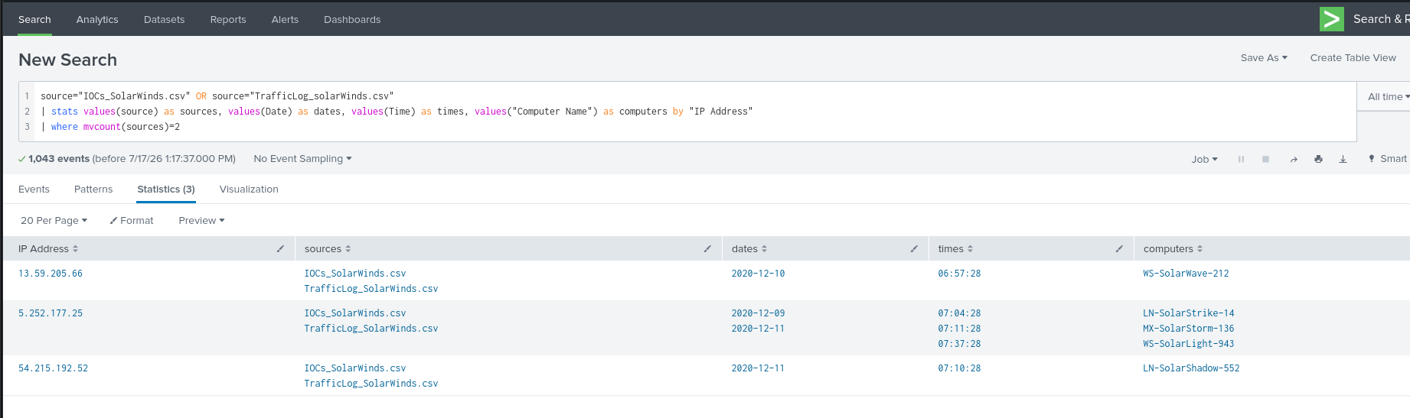

SolarWinds Match #2
Matched IP address: | 13.59.205.66
The event date(s) and time(s): | 2020-12-10 06:57:28
Affected computer(s): | WS-SolarWave-212
Screenshot of the match in Splunk


Investigation 2: Scattered Spider (Required)
Scattered Spider Match #1
Matched indicator: | ciscoacclink.com
The event date(s) and time(s): | 2024-09-15 14:23:17
Affected computer(s): | WS-IT-204
Screenshot of the match in Splunk
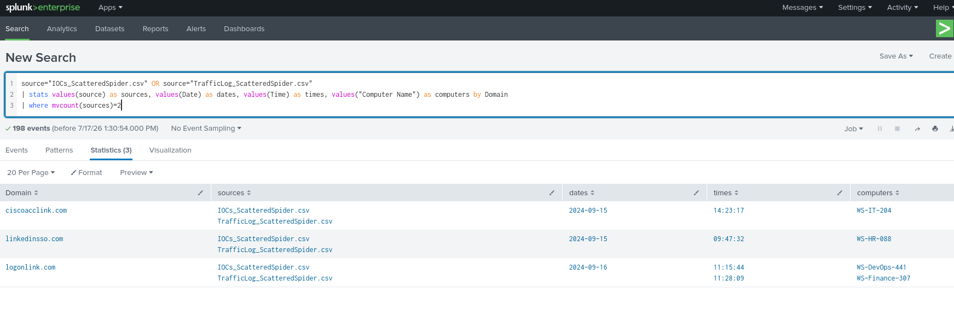

Scattered Spider Match #2
Matched indicator: | linkedinsso.com
The event date(s) and time(s): | 2024-09-15 09:47:32
Affected computer(s): | WS-HR-088
Screenshot of the match in Splunk


Written Analysis (Required)
Write a short analysis (3 or more sentences) that addresses each of the following prompts:
- What did you find in each investigation? How many systems were affected, and over what time period?
- Compare the VirusTotal results across both investigations. What does the difference (or similarity) tell you about how threat infrastructure ages?
- These were two separate incidents, years apart. What does that suggest about PathCode's security posture?

To receive full credit, make sure you reference specific data from the investigations in your response (e.g., actual IPs, domains, computer names, or dates found).
In Investigation 1, I identified 3 IP matches (5.252.177.25, 13.59.205.66, 54.215.192.52) between the SolarWinds IOC list and PathCode's traffic logs, affecting 5 systems between December 9–11, 2020, with 5.252.177.25 alone contacted from three separate workstations (WS-SolarLight-943, MX-SolarStorm-136, LN-SolarStrike-14). In Investigation 2, I identified 3 domain matches (linkedinsso.com, ciscoacclink.com, logonlink.com) affecting 4 systems between September 15–16, 2024, with logonlink.com contacted from two machines (WS-Finance-307, WS-DevOps-441). VirusTotal detection ratios were surprisingly consistent across both investigations the 2020 SolarWinds IPs scored 13/91, 8/91 and 9/91, while the 2024 Scattered Spider domains scored 12/91, 9/91, and 13/91. This suggests threat intelligence vendors continue flagging known malicious indicators long after the underlying infrastructure goes cold, so detection ratio reflects historical attribution more than real-time danger. The fact that PathCode suffered two unrelated compromises four years apart a software supply chain attack in 2020 and a social-engineering/credential phishing campaign in 2024 points to a recurring detection gap across fundamentally different attack surfaces, rather than a single fixable weakness, suggesting the organization needs broader, layered monitoring rather than a fix targeted at one attack type.

Stretch Challenge (Optional)

SolarWinds Match #3
Matched IP address: | 54.215.192.52
The event date(s) and time(s): | 2020-12-11 07:10:28
Affected computer(s): | LN-SolarShadow-552
Screenshot of the match in Splunk


Scattered Spider Match #3
Matched indicator: | logonlink.com
The event date(s) and time(s): | 2024-09-16 11:28:09; 2024-09-16 11:15:44
Affected computer(s): | WS-Finance-307; WS-DevOps-441
Screenshot of the match in Splunk


Submission Checklist
👉Check off each of the features you have completed. You will only be graded on the features you check off.

Reflection
- Reflection Question #1 answered above
- Reflection Question #2 answered above

Required Challenges
- SolarWinds Match #1
- SolarWinds Match #2
- Scattered Spider Match #1
- Scattered Spider Match #2
- Written Analysis (responding to prompts A, B, and C)

Stretch Challenge
- SolarWinds Match #3
- Scattered Spider Match #3

